Operation Manual

Digital Wireless RF-Modem
Model: iRF-1000M(433Mhz)/2000M(219Mhz)

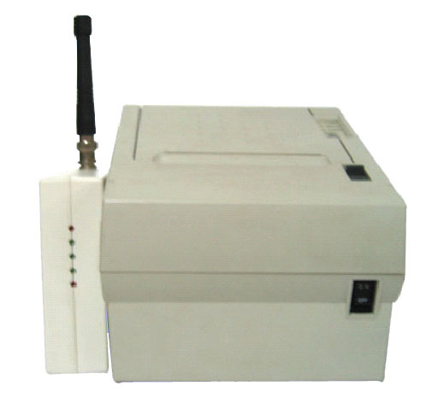

ScannWorld Co., Ltd.

TABLE OF CONTENTS

1. General Specification-------------------------------------------3
1.1 Part Identification

2.Installation
2.1 Step one - Before you Install
  - Step two -Select Master and Slave
- Setting Dip Switch for PTP mode (Point to Point)
- Setting Dip Switch for Multi mode
2.3 Step three - Select Slave(s) ID
2.4 Step four - Select Frequency
2.5 Step five – Cable connection

3. Software Application
3.1 How to set in your PC-Pos
3.2 For End-User ---------Important
3.2.1) How to check printer error.
3.2.2) How to check communication Error

4. Led Indicator

5. Specification

6. Demo Program

1. General Specification
- 1 Part Identification
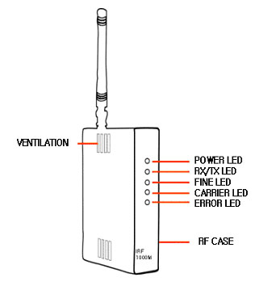
-Front-

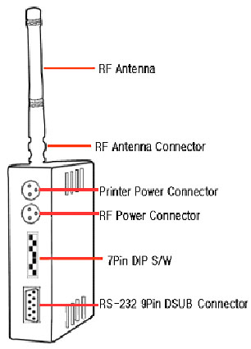

-Back-

2. Installation

Our RF-Modem has 2 vesrsions, One is PTP(Point to Point) and
the other is Multi-Point one.

In case of PTP, you can use very simple configuration without
POS Program change(like Multi-Point version)
By just connecting current your POS/ECR and additional 1 Printer,
you can make the configuration easily.

Step One - Before you install
Check below accessories for installation. If something missing, ask dealer for this ones.
Your dealer may supply below accessories depending on number of your printer.
(Following ones are NOT included in this box.)

For Master(Transmitter) : connecting cable (9pin-9pin)
Power Adapter(DC 24V, 200mA)

For Slave(Receiver) : Power Adapter(DC 24V, 200mA)
Power Cable (Modem to Printer)
Connecting Cable (9Pin-25Pin)

- Some cheap adapters may cause bad radiation which interrupt Modem’s Signal. Use approved Power Adapter or your Dealer’s Recommending ones.

- Above four accessories are supplied as “Option”. So when purchasing, please check them with your dealers.

- For technical reason, we do not supply cable more than 2m.

Step Two

A Setting Dip Switch for PTP mode (Point to Point)
]
Identify modem as Master or Slave by Dip Switch No 1~4 in the back.

Make Switch #1,2,3 and 4 Upper position(On Status) then
now you have PTP(Point to Point) function from Multi-Point.

** note: On is to make the Dip Switch upper position.
Off is to make the Dip Switch low position.

- You should make same Dip Switch setting both for Master & Slave

PTP
Channel Select
1 2 3 4 5 6 7

Pos
(Master)

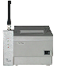 --PTP setting example--
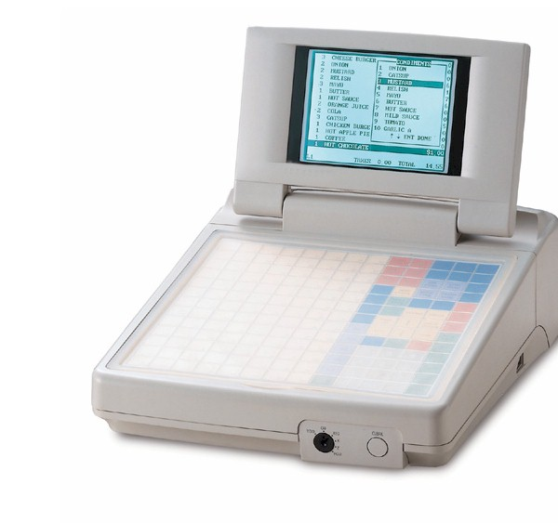

ECR/Pos Printer
-Master and Slave Configuration for PTP-

Step Two

B. Setting Dip Switch for Multi mode
Identify modem as Master or Slave by Dip Switch No 4 in the back. (See below picture switch no 4)

Switch On(Up) – Master, Switch Off(Down) – Slave
** note: On is to make the Dip Switch upper position.
Off is to make the Dip Switch low position.

Master : connected with POS
Slave : Connected with Printer.

*There is no mark on the packing box to show “Master” or “Slave” (This modem is convertible to both as selecting the Dip Switch On or Off position.
* When you choose Master, please turn switch #1~3 off.
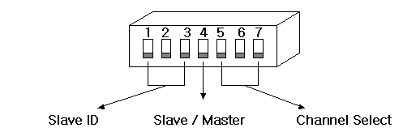(to use several printers) ( to use several POS for
different frequency selecting)
Pos
(Master)

Printer #1 (Slave #1)
Printer#2 (Slave #2)
Printer#N (Slave #N)

-Master and Slave Configuration for multi-
Step Three – Select Slave ID (For Multi Only)

Identify slave by Dip Switch (No1~3)
 | Dip S/W 1 | Dip S/W 2 | Dip S/W 3 | 1 2 3
Slave #1 | Off | Off | Off | ↓ ↓ ↓
Slave #2 | Off | Off | On | ↓ ↓ ↑
Slave #3 | Off | On | Off | ↓ ↑ ↓
Slave #4 | Off | On | On | ↓ ↑ ↑
Slave #5 | On | Off | Off | ↑ ↓ ↓
Slave #6 | On | Off | On | ↑ ↓ ↑
Slave #7 | On | On | Off | ↑ ↑ ↓
Slave #8 | On | On | On | ↑ ↑ ↑

- One Master can have 8(1~8) slaves. And slave must have different ID. If two or more slaves have same ID, the modem does not work.
- Please be careful not to change dip switch no 4-7

Step Four – Select Channel Frequency (For PTP and Multi)
This is for you to use several POS in one place as Master Modems’ Frequency not being mixed with others, or to avoid Frequency Mixing with nearby other shops who are using same Modems.

You can choose frequency by Dip Switch # 5~7
Master & Slave should have the same frequency. If one of the slave have different
Frequency, it does not work. You can match the Frequency among Master and Slaves by these Dip Switch selection in same Channel Nr for Master and Slaves.

Selected frequency may be interrupted by each different surroundings.
So if Modem does not work properly, try the other channel.
You can choose 1 out of 8 (or 5) channels to make proper working as follows:

* Identify Frequency by Dip Switch in the back (No5~7)
Channel #  (433Mhz Range, Europe) | Channel #  (216Mhz Range, USA) | 5 | 6 | 7 | 5 6 7
Ch 1  (433.050 Mhz) | Ch 1  (219.025 Mhz) | Off | Off | Off | ↓ ↓ ↓
Ch 2  (433.350 Mhz) | Ch 2  (219.050 Mhz) | Off | Off | On | ↓ ↓ ↑
Ch 3  (433.750 Mhz) | Ch 3  (219.070 Mhz) | Off | On | Off | ↓ ↑ ↓
CH 4  (433.950 Mhz) | CH 4  (219.100 Mhz) | Off | On | On | ↓ ↑ ↑
CH 5  (434.050 Mhz) | CH 5  (219.125 Mhz) | On | Off | Off | ↑ ↓ ↓
CH 6  (434.200 Mhz) | No channel | On | Off | On | ↑ ↓ ↑
CH 7  (434.500 Mhz) | No channel | On | On | Off | ↑ ↑ ↓
CH 8  (434.775 Mhz) | No channel | On | On | On | ↑ ↑ ↑
* note: In case of 219Mhz, there is only 5 different channels available.

Step Five – Cable Connection (For multi & PTP)
POS <-> Master Modem : 9 Pin Serial Cable
Master Modem <-> Power Adapter
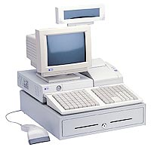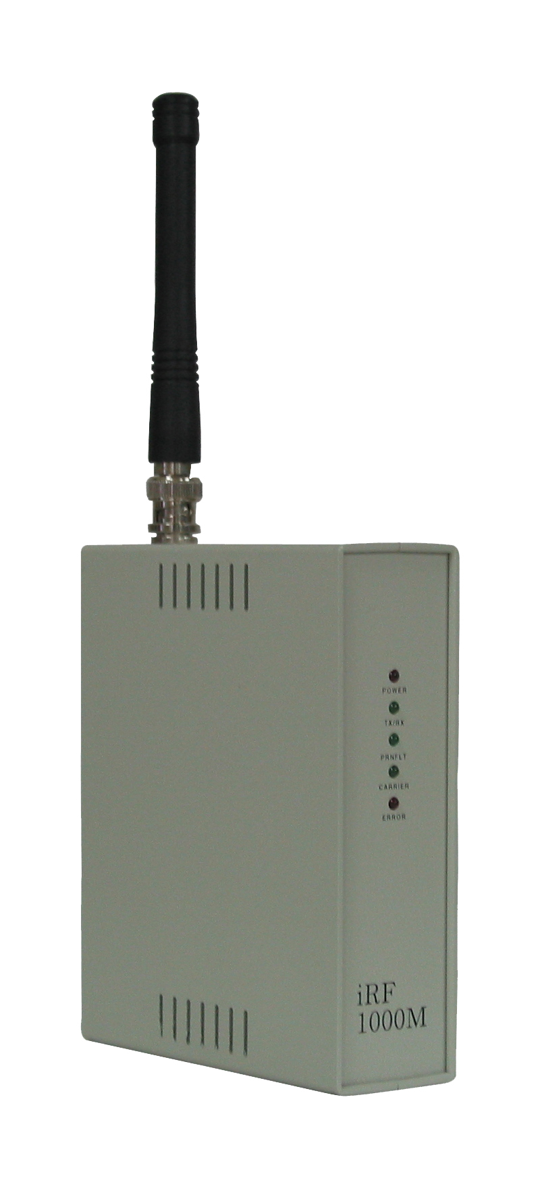

Printer<->Slave Modem : 25 Pin Cable for Slave Modem and 9 Pin Cable for Printer

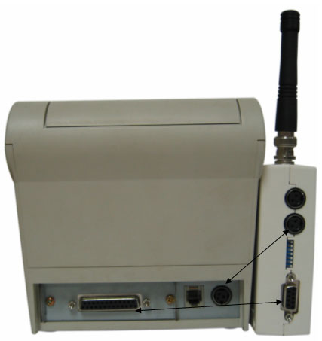

<RF TO PRINTER IS 25PIN AND 9PIN SERIAL CONNECTOR>
<PRINTER POWER TO RF POWER IS EQUAL(3PIN POWER CONNECTOR)>

3. Software Application

  - How to set in your PC-Pos

For PTP : You do not need modify your PC-Pos program.
For Multi : Your supplier will modify your PC-Pos program, please contact your supplier.

!!!! For PC-Pos Programmer & Engineer, please see chapter 5 & 6 for detailed specification for multi function.

3.2 For End-User ---------Important
This modem is smart enough to check when your data is not printed.
Before you start this modem, you need to check following for powerful use.

3.2.1) How to check printer error. (For multi and PTP)

Before you run your Pos, you need to make following error intentionally and check error message is appeared on your Pos Monitor. Please make your printer status as follows one by one, and check error message case by case.

Printer Jam
Out of Paper
Power Off
Cover Open

3.2.2) How to check communication Error (For multi and PTP)

Under your surroundings, RF-modem sometimes do not work properly due to frequency interrupt.

For PTP : In case of communication error, you will find error message in your monitor. So, when you find error in your Pos, you should check both printer and modem status.

For multi : “Data Error Message will be appeared when there is frequency interrupt in spite of normal condition. If this “Data Error Message” appeared often, you may change “Frequency channel” until you find optimized channel.

4. LED Indicator
Below led will guide you status of RF-Modem and dedicate error status.

* LED ON : ● LED OFF : ○
LED | POWER  ON | RAM  Error | Timer  Error | Modem  Error | Communi-cation OK | Re-send
Power ON/OFF | ●
TX/RX | ●
FINE |  |  | ● | ● | ●
CARRIER |  | ● |  | ● |  | ●
ERROR |  | ● | ● | ●

Power ON/OFF and TX/RX LED

When you connect necessary cables to POS, Printer and RF-Modems then if you

put power,

- Power ON/OFF LED : ON

- TX/RX LED : ON

should be shown. Even if you put power and set up all cables well, if above 2 LEDs are

not on, there may be critical problem for RF-Modem itself.
Then please contact your supplier for checking it.

In case of your data from POS has been transmitted through 2 RF-Modems well,

- TX/RX LED and Fine are 2~3 times blinking and off.
This will happen every time of data transmission. Then it is working normal.

LED for  Master modem | Slave  No response | TX Fail Over | Printer Error
FINE |  | ● | ●
CARRIER | ● |  | ●
ERROR | ● | ● | ●
For Error check of Master RF-Modem( if print is not made), there are 3 cases as
follows:

-For reference, any 3 cases, the Error LED will be on status per each problem.

Case 1 . Carrier LED : ON
Error LED : ON

This is critical RAM error of Salve Modem and you need to make your
RF-Modem checked by your supplier or dealers.

The Slave Modem does not respond anyway. This kind of problem will
not always happen. (very rare case.)

Case 2. Fine LED : ON
Error LED : ON

The Transmitted Data is too big(more than 4KB) so Slave Modem received
too much data. Please reset power off and on again for the Slave Modem clearing
and reduce the data to be sent to Slave Modem.

Case 3. Printer Error
Fine LED : ON
Carrier LED : ON
Error LED : ON

In case of Printer Power Off, No Paper, Paper Jam, Paper Out, it will happen.
Please clear Printer Error and it will work again.

LED for  Slave modem | Print error
FINE | ●
CARRIER | ●
ERROR | ●

For Salve RF-Modem, you can have “Printer Error” checking

like above case 3.

For above frequent possible problem cases, they can be solved by above method.
If not, we recommend you contact your dealer for more service or problem solution.
But for more complicated information on LED ON/OFF, it is for technician or engineer level service purpose so it is not necessary for common end- users.

5. Specification

Important !
** Note: Below is for programmer & H/W engineer setting and repair.
** For programmer : Please modify your data ID is fixed according to our instruction
for multi function.
Please modify your PC-Pos program to accept communication error
Printer error and make this error signal appeared on screen for
End-user. Please check following information for easy modification.

5.1 General Specification
Channel | iRF1000M_400(8ch)
Communication Speed | Pos to Modem (9600) / Modem to Modem (4800)
Interface | RS232C
Antenna Impedance | 50Ω
Antenna length | 11/34Cm
TRANSMISSION | Transmission  Frequency | iRF1000M_400 (433.050-422.200MHz)
TRANSMISSION | Transmission  Generating power | 10mA
TRANSMISSION | Electric wave  Formula | F2D
TRANSMISSION | Frequency Deviation | 1.53KHz
TRANSMISSION | Frequency Band Width | 16KHz
TRANSMISSION | Spurious Double Header | 40dB more
TRANSMISSION | Base Frequency | 12.8000MHz
TRANSMISSION | Oscillation Formula | PLL Oscillation
TRANSMISSION | Carrier  Generating Power | C3356
TRANSMISSION | Transmission Time | 40 sec under (30 sec)
TRANSMISSION | Transmission  Pause Time | 1sec
RECEPTION | Reception Frequency | 219.025-219.125MHz  433.050-422.200MHz
RECEPTION | Reception Formula | Double super heterodyne formula
RECEPTION | Middle Frequency | 21.4MHz
RECEPTION | Carrier  Perception Sensitivity | 2μV
RECEPTION | Greatest  Reception Sensitivity | 1μV under
RECEPTION | Oscillation Formula | PLL Oscillation
RECEPTION | Secondary Electric wave discharge | -54dBm under

5.2. Electrical Characteristics
1) Supply voltage : +24 VDC
2) Current Consumption : 90mA - 200mA

5.3 Physical Characteristics

5.4 Internal Buffer
1) Receive Buffer : 10K
Transmit Buffer : 4K

NOTE : Maximum data transmit : 4kbyte Data

5.5 Interface
5.5.1 RS232C Serial Interface
5.5.2 Specifications
Data Transmission : Serial
Synchronization : Asynchronous
Handshaking : DTR/DSR control
Signal level : Logic “1” / OFF (-3 to +15V)
Logic “0” / ON (+3 to +15V)
Baud rate : 9600 bps
Data word length : 8bits
Parity : None
Stop bit : 1
Connector : Female DSUB-9 pin connector

Note : Interface Setting is fixed.
Handshaking should fix DTR/DSR for Printer Error check.

<RF Module to Printer Serial Interface>
5.5.3 Interface connector terminal assignments and signal function
Pin Number | Signal Name | Signal direction | Function
2 | RXD | Output | Transmit Data
3 | TXD | Input | Receive Data
4 | DTR | Output | This signal indicates Modem Communication Status  ON(Logic 0) : Modem can receive data  OFF(Logic 1) : Modem cannot receive data
5 | SG | - | Signal Ground
6 | DSR | Input | This Signal indicates the host Communication Status.  ON(Logic 0) : The host can receive data  OFF(Logic 1) : The host cannot receive data

5.5.4 Serial interface connection example

Host ------------------ Modem
TXD------------------ RXD
RXD------------------ TXD
DSR ------------------ DTR
SG ------------------ SG
DTR ------------------ DSR

5.6 Connector
5.6.1 Interface Connector Figure

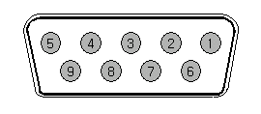
<Female DSUB-9PIN Connector Figure>

5.6.2 Power Connector
Pin Number | Signal Name
1 | +24VDC
2 | GROUND
3 | NC

5.6.3 Power Connector Figure

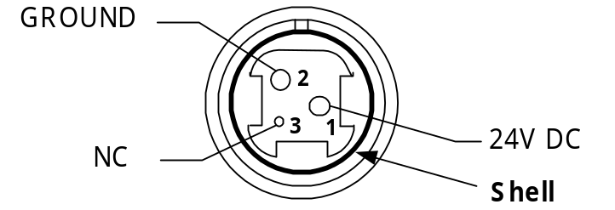
<Power Connector>
5.7 Frame structure
To be advised.

5.8 Transmit Data Format (For multi only)
Please contact us for information.

5.9 ERROR FORMAT from printer (For multi only)
Please contact us for information.
6. Demo Program (For multi only)

Important !

** Note: Below is only Example in our Demo Program in Windows.
This program will be useful when you could not find the problem in your PC-Pos.

6. 1 Operation
You can find out our S/Ware in Diskette(1.44MB) through your dealer.

Please put it in the FDD Drive in PC/POS then go to “A” Drive for it and click “ then you can see demo.exe file.

- Run “demo.exe” as clicking and you can see below window:
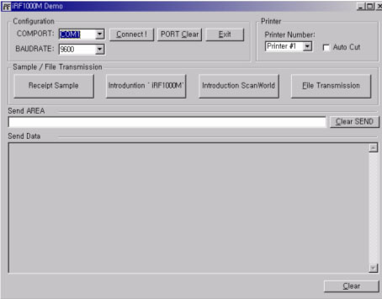

- Setting
You need to set your printer port, Baudrate as follows:

Your port : Com1
Baudrate : 9600
Auto cut : Check(mark “V”)

Then click “Connect” and check connection has been done.

- choose printer #1 or printer #2 or up to #8 according to how many printers you want to use.
- .Click on of button(Receipt Sample or Introduction iRF-1000M or Introduction Scannworld) for sample data sending.
- Check if your printer is working well according to order of Demo printer

6.2 Error Check function.

Our Modems have function to recognize the following Error Message but your Dealer needs to make and install the Error Check Program who has received our Program Support.

If there are

6.2.1) Printer Error: Paper Jam
Out of Paper
Power Off
Cover Open

You can find out feed-back message : Slave is off 1 Error !
In the bottom line of the your Monitor display.
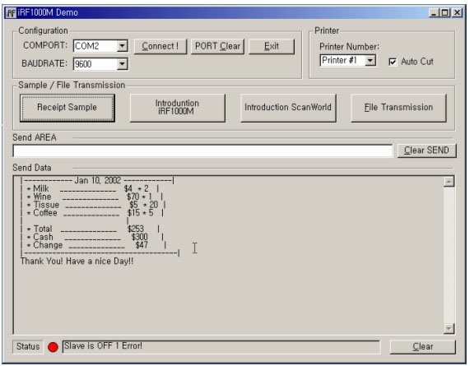

Then please check your Printer Status and fix it.

6.2.3) Communication data Error
If the modem would not be communicate the data, you could show the messages “Data error” like 3 cases as bellows on POS’ display :

- Communication error
- Buffer overflow
- QBuffer overflow

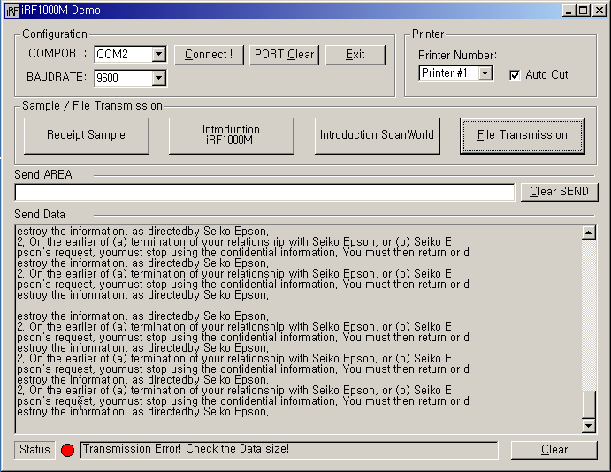
* Please check you following right installation guide and check following.
- Make sure Master CH & Slave CH as same
- Make sure Printer I/D setting is right
- Distance between Slaves should be more than 2M
Rocommanded position of Master modem would be higher than Slave modem

--------End of Manual--------

